Sai Manoj Gunakala

Web Technologies

May 2, 2017

# Development Project 3

Screenshots.

1. Database.

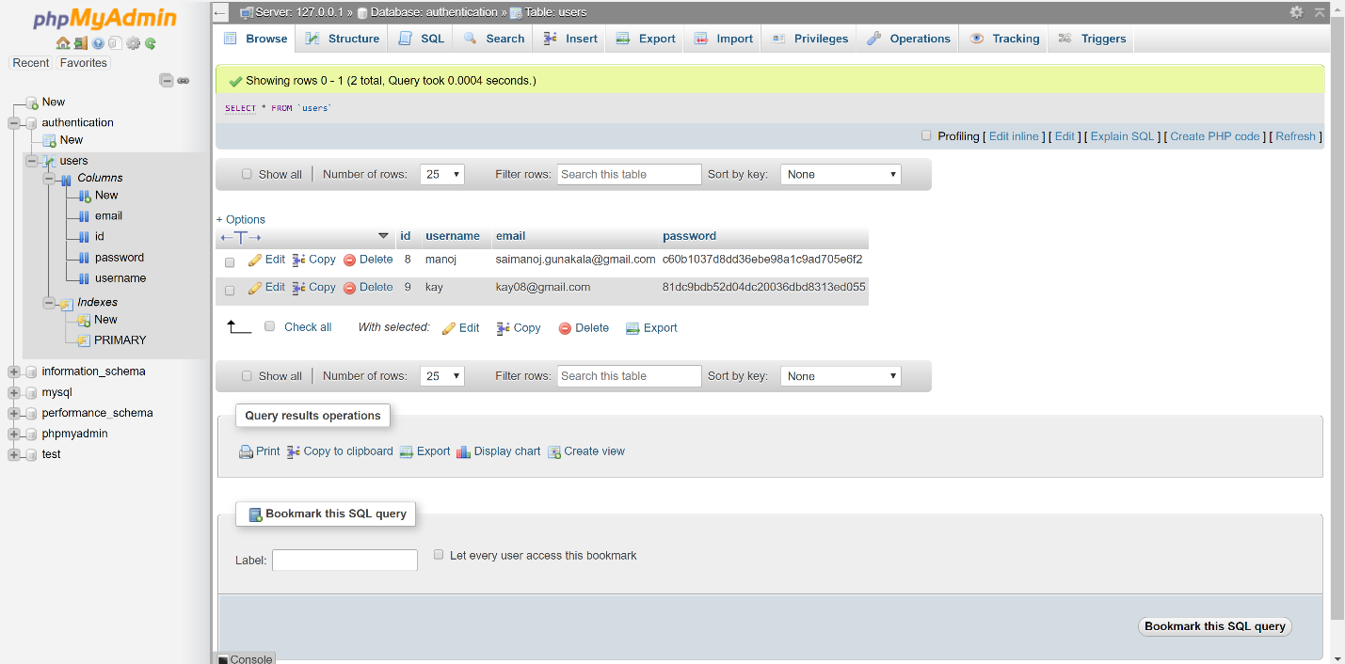

1. Webpage for registration.

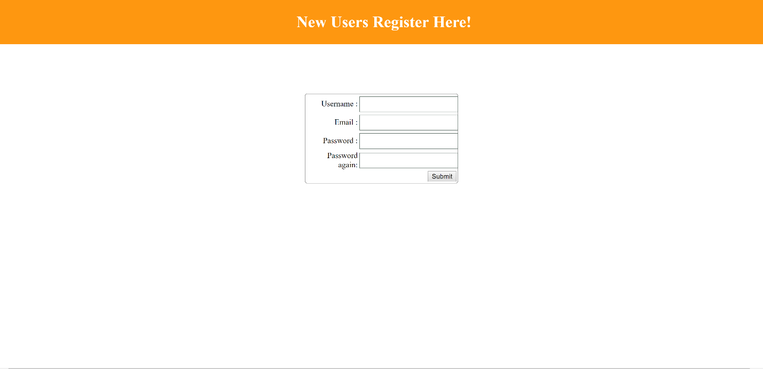

1. Webpage after registration.

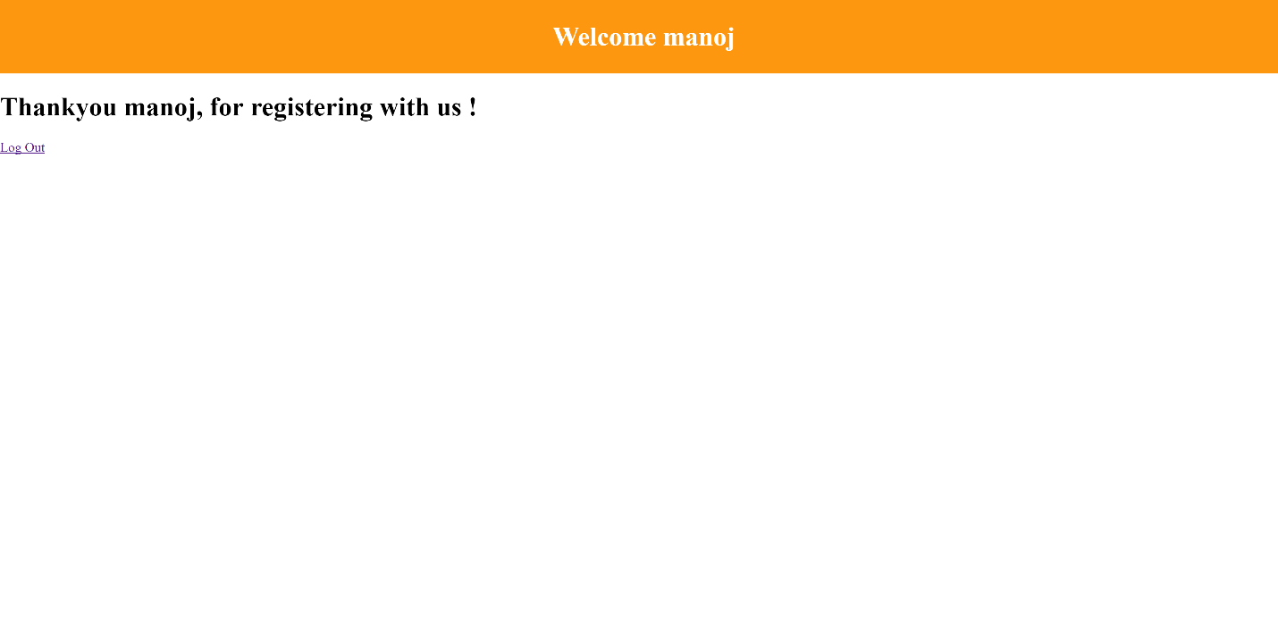

1. Screenshot for login page.

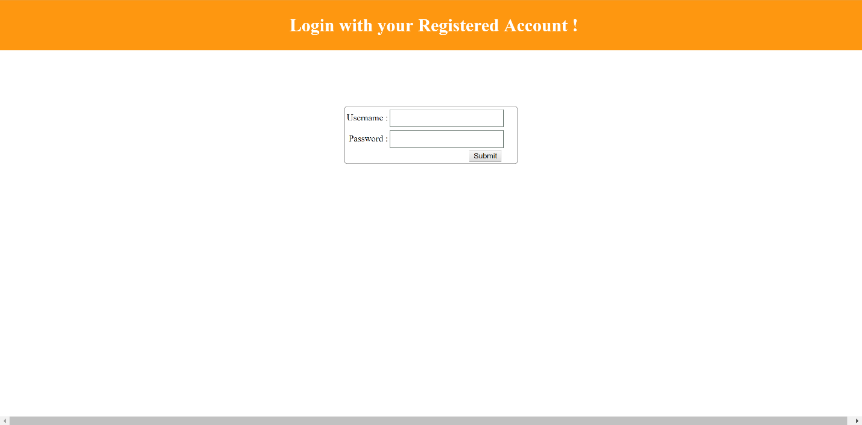

1. Page after login.

